3. Data Analysis:

○ Write SQL queries using the dimension and fact tables to derive actionable insights and validate data accuracy.

Analysis:

1 .Total Loan Amount Disbursed by Geography

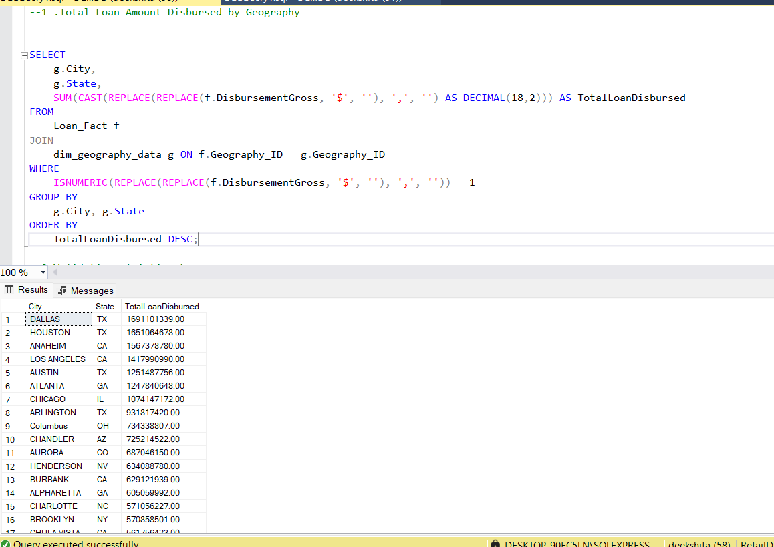

2.Number of Loans Approved by Year

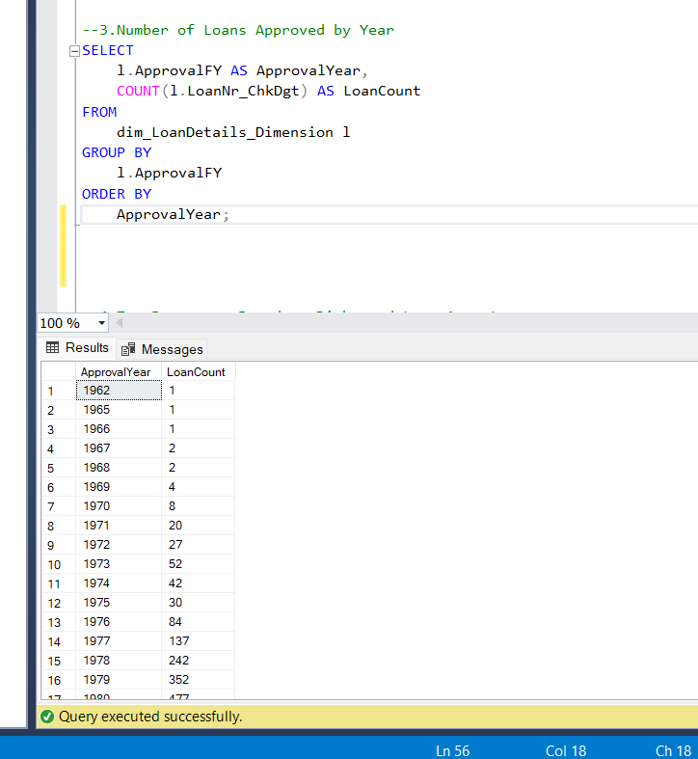

1. Validation of Active Loans

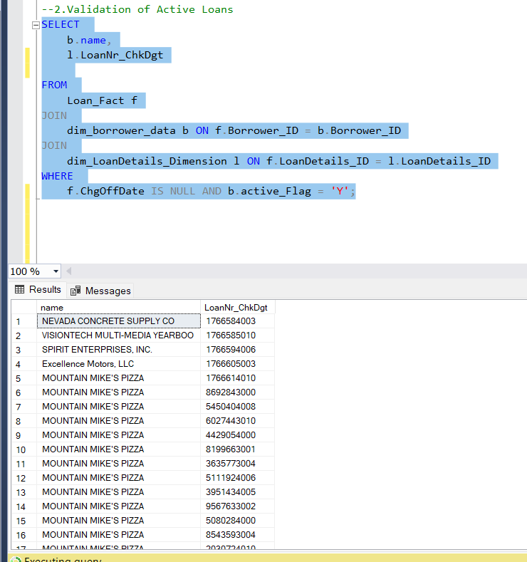

4)Top Borrowers Based on Disbursed Loan Amount

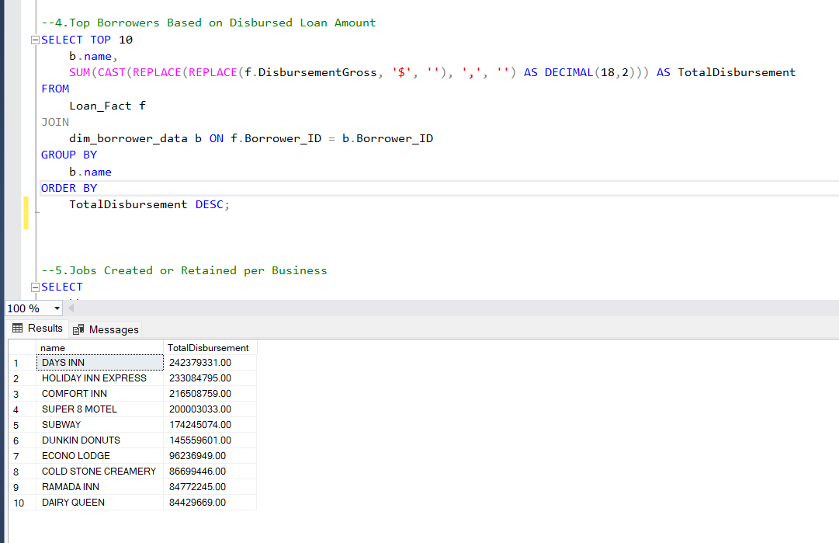

5)Jobs Created or Retained per Business

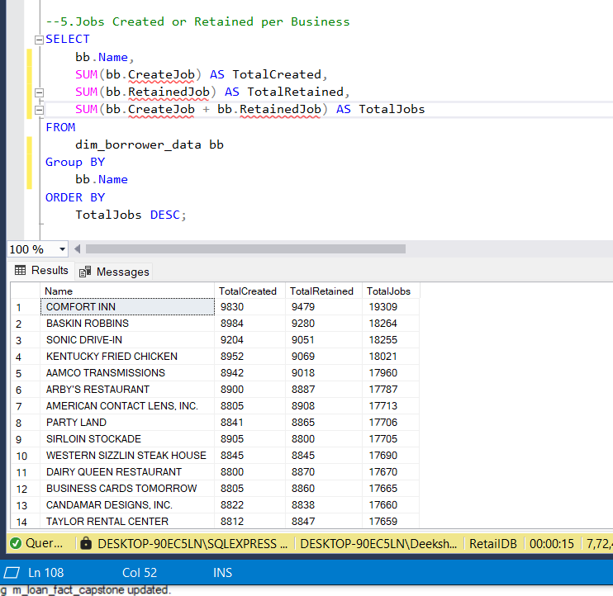

-6.Loans by Urban vs. Rural Areas

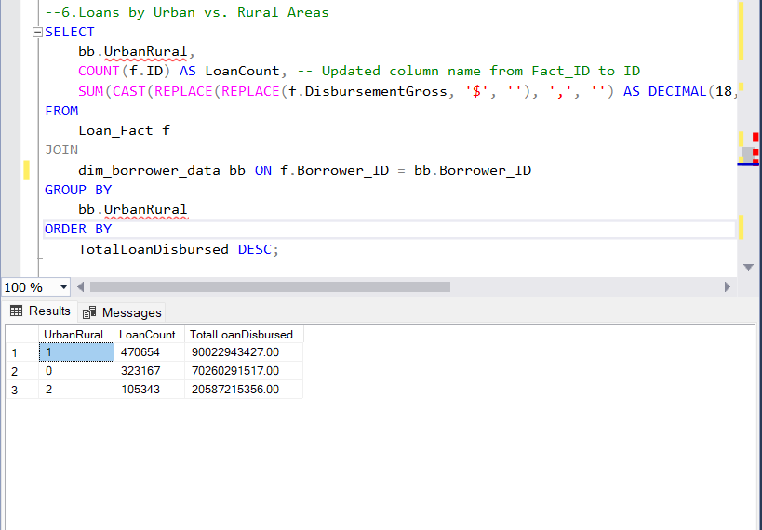

7)Loans by Bank and Geography

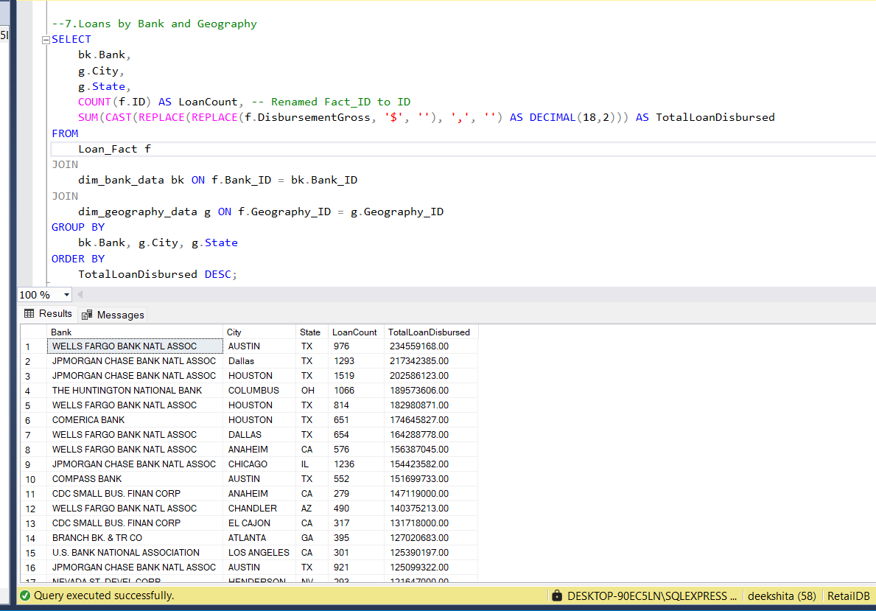

8)Loan Disbursement Trends by Year

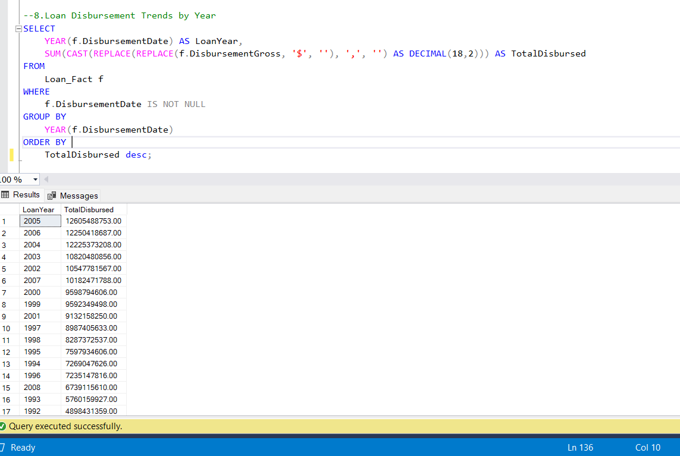

PYTHON FLASK- DASHBOARD CHARTS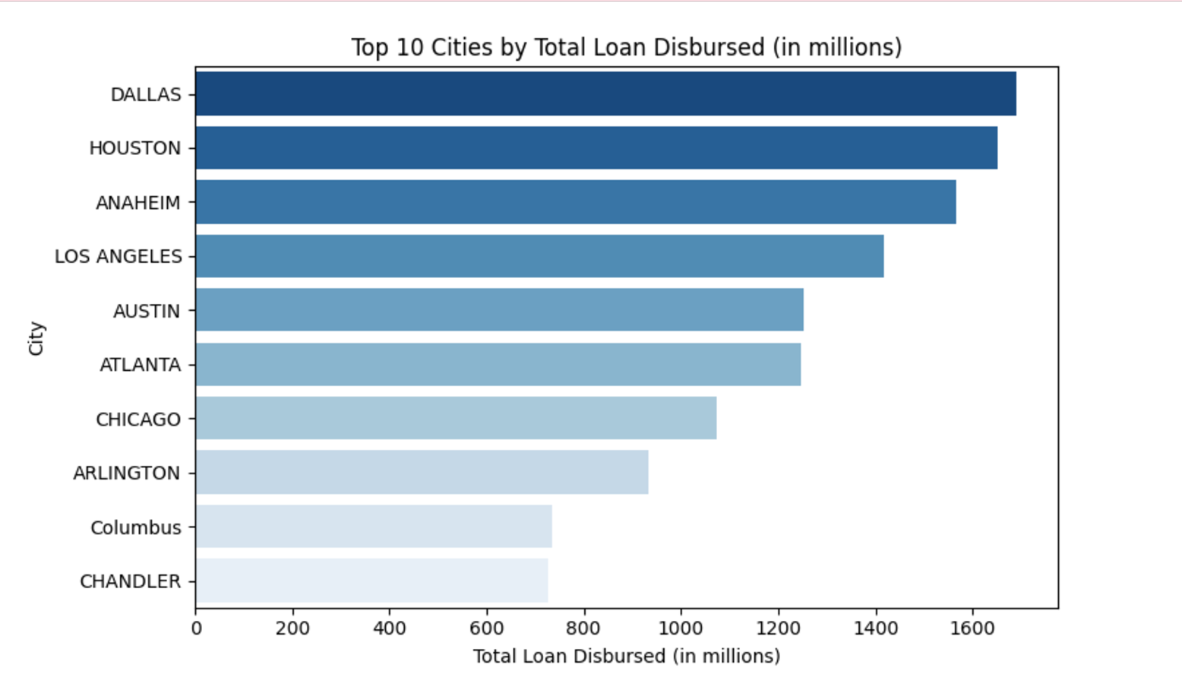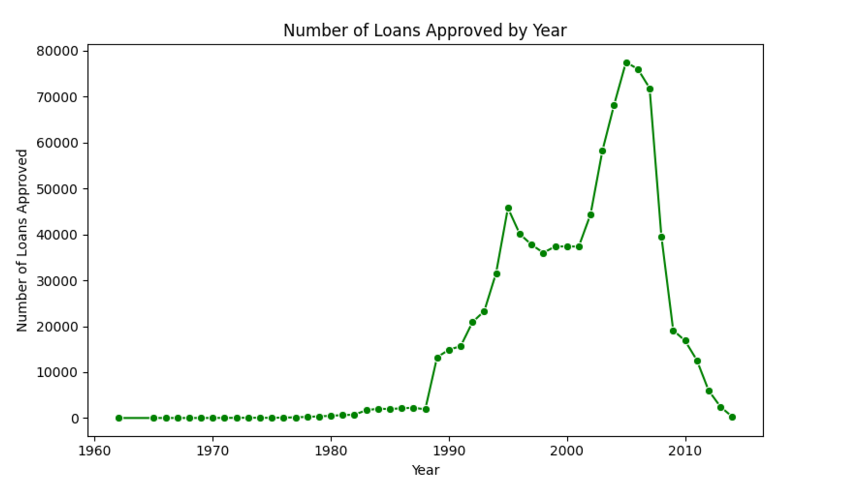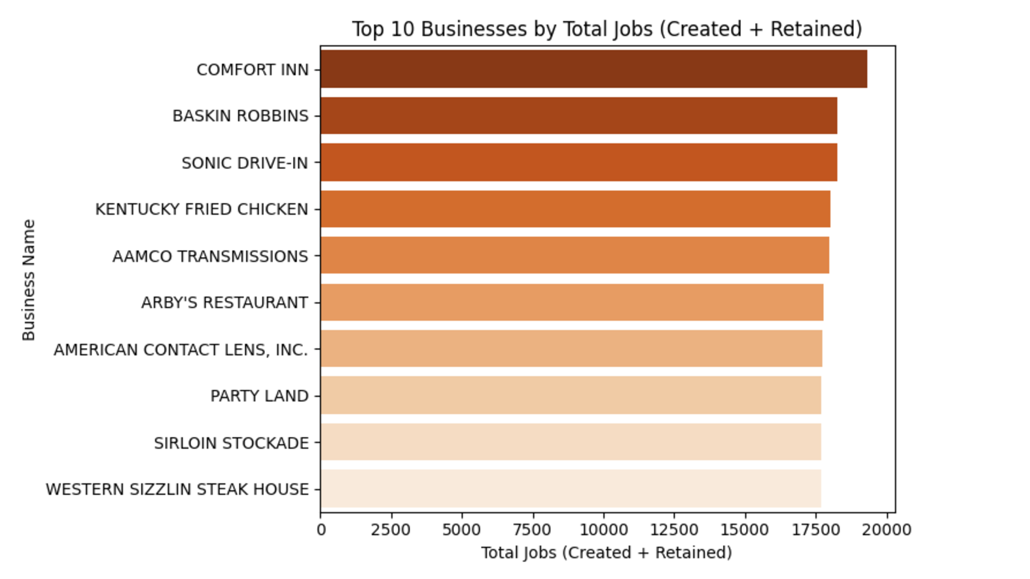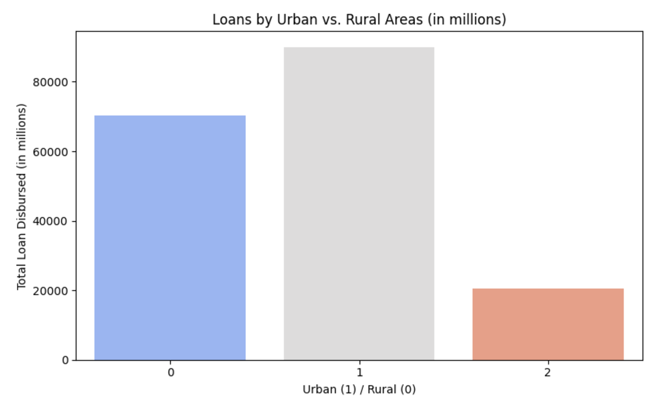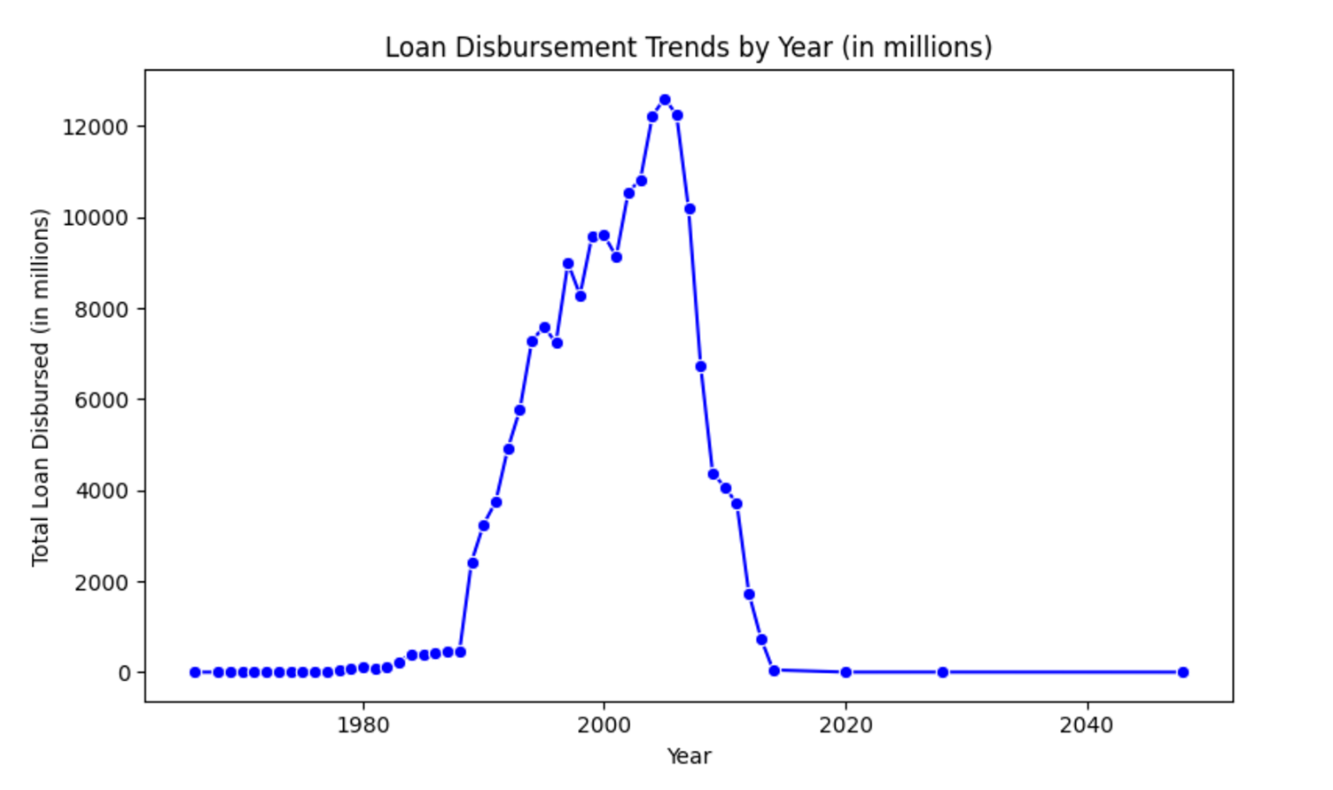

INSIGHTS FROM THE SQL QUERIES (ANALYSIS)

1. -->Highest loan amount has been disbursed from Dallas, i.e $ 1691101339.00

-->Followed by Houston,anaheim and los angeles

-->Least amount disbursed in winfield city

1. There are around 736465 active loans for small bussinesses in totality
2. Data of approvals from 1962 to 2014 is given , most approvals are given in the year 2005
3. Top 10 borroweres are:

DAYS INN 242379331.00

HOLIDAY INN EXPRESS 233084795.00

COMFORT INN 216508759.00

SUPER 8 MOTEL 200003033.00

SUBWAY 174245074.00

DUNKIN DONUTS 145559601.00

ECONO LODGE 96236949.00

COLD STONE CREAMERY 86699446.00

RAMADA INN 84772245.00

DAIRY QUEEN 84429669.00

1. Most jobs were created by COMONFORT INN , and the bussiness also retained most of the jobs it has provided, followed by baskin robins
2. There are 470,654 loans from urban area , adding up to $90,022,943,427.00

There are 323,167 loans from rural area , adding up to $70,260,291,517.00

There are 105,343 loans from sub-urban area , adding up to $20,587,215,356.00

1. Wells Fargo bank in Austin has disbursed the highest loan amount $ 234559168.00, followed by Jpmorgan in Dallas.
2. Most amount of loans have also been disbursed in the year 2005, followed by the year 2006.